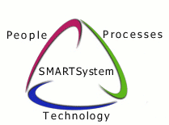
SMARTECH and Associates, LP
Electronic Funds Transfer

Dear Partner;
As Smartech continues to grow and forge ahead through difficult economic times, the staff and I have developed a strategy to take advantage of your skills and our place in the market to our mutual benefit. The goal of our new strategy is to put you to work more often and more efficiently. We do this to prepare for even more growth in the future, and we cannot grow without you.
Your payments will be transferred directly into your bank account 30th days after each call closed. All EFT and checks are mailed or sent electronically every Friday. Depending on your bank there is usually a two day grace period before the funds are deposited in your account. If you want to keep receiving a check instead, it can take up to 45 days to reach you depending on your location and the mail service.
To access the EFT information form, click on the following link while holding the ‘ctrl’ key http://www.smartech-csi.com/eft/login.aspx this will access our secure server. The User ID is “techinfo” and the Password is “eftaccount”. Please fill out the form completely.
Once we have received your banking information we will send a pre-note to verify the routing numbers. You will continue to receive live checks until the pre-note period has expired.
If you have not already received a username and password for our Alert Software System, one will be sent to you shortly. You will be able to view all current and past payments from this system, under “Contractor Payments”.
Here is where you can find the appropriate information.
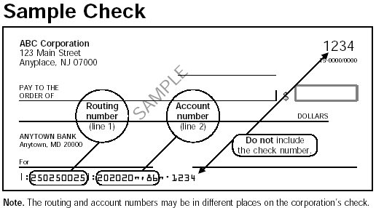
Routing Number is the number between the two transit symbols ( )
in the MICR encoding at the base of the check or deposit slip. The Receiving
Account Number will be evident as the other part of the MICR check encoding.
Until then,
David Moore
CEO
Smartech & Associates, LP.

